Reading: Multiple Choice

Přečtěte si pět krátkých textů. Na základě informací v textech vyberte k úlohám 1-5 vždy jednu správnou odpověď A-D.

________________________________________________________

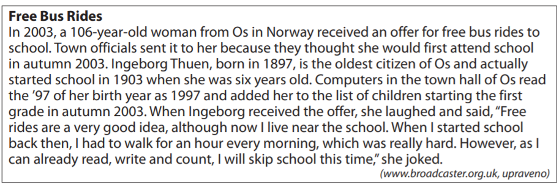
- Why was the woman offered free bus rides?
She was offered free bus rides:
- because of her hour-long walk to shool every morning.
- because she was the oldest person in the town.
- because she wanted to start school.
- because of a computer mistake.

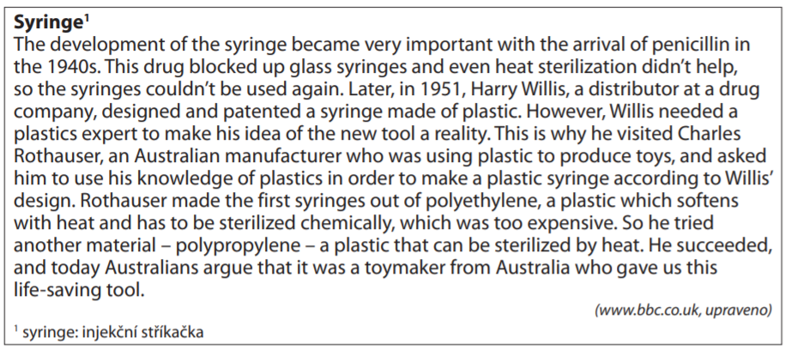
- What did the Australian toymaker do for hte development of syringes?
- He patented a plastic syringe.
- He designed a plastic syringe.
- He produced the first plastic syringe.
- He discovered a new way of sterilizing syringes.

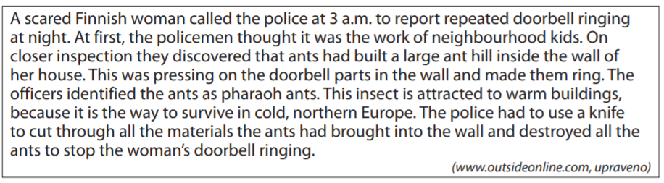
- What is the most suitable title for this article?
- Ants Survived Winter Thanks to the Police
- Woman Scared by the Police at Night
- Children Making Trouble at Night
- Strange Doorbell Ringing
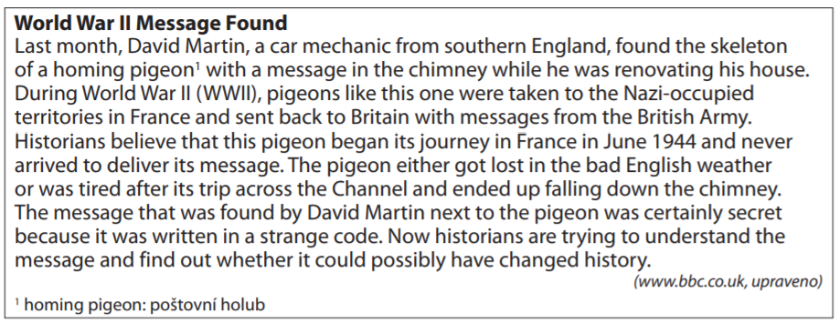
- What does the article say about the discovered top secret message?
- It was lost in France during WWII.
- Historians discovered it in a chimney.
- The Nazis sent it to Great Britain during WWII.
- Scientists are unable to read its meaning at present.

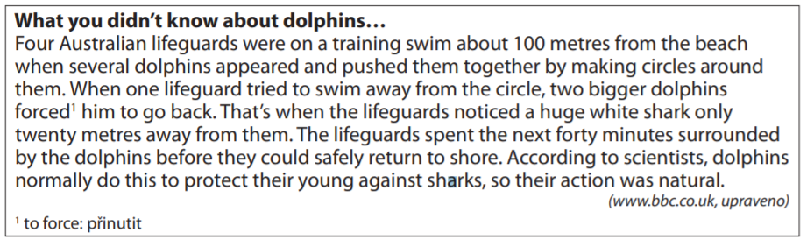
- What did the dolphins do?
The dolphins:
- made a circle around a white shark.
- protected lifeguards against a shark.
- trained with lifeguards to save swimmers.
- made the lifeguards to go back to the shore.

Co jsem se touto aktivitou naučil(a):
………………………………………………………………………………………………………………………………………………………………………………………………………………………………………………………………………………………………………………………………………………………………………

Autor: Lýdie Valešová
Toto dílo je licencováno pod licencí Creative Commons [CC BY-NC 4.0]. Licenční podmínky navštivte na adrese [https://creativecommons.org/choose/?lang=cs].

